14) Write a C program to generate ‘n’ prime numbers using break statement.

#include<stdio.h>

int main()

{

int num,i,pri=2;

printf("Enter n value:");

scanf("%d",&num);

while(num)

{

for(i=2;i<pri;i++)

{

if(pri%i==0)

{

break;

}

}

if(i==pri)

{

printf("\n%d\n",pri);

num--;

}

pri++;

}

}

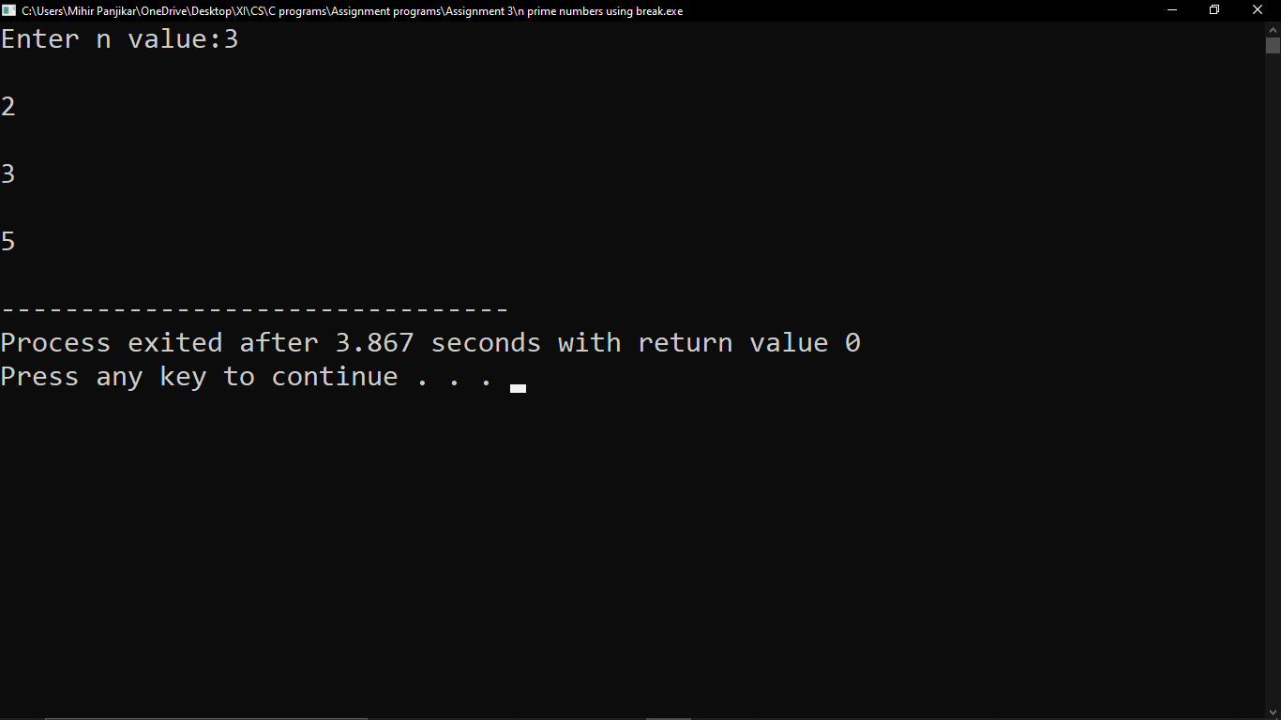

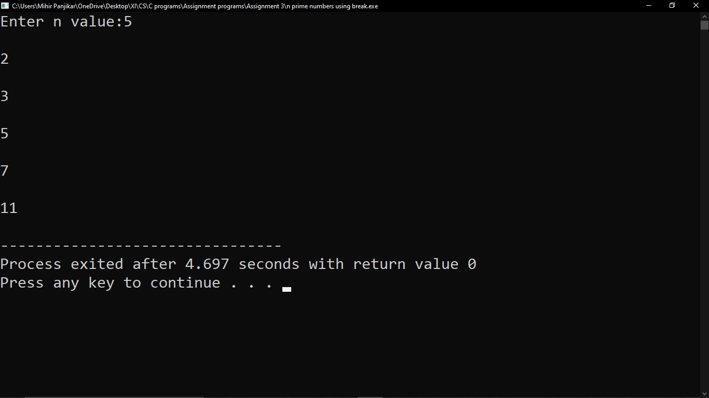

15) Write a C program to calculate the area of a sphere and cone depending on user’s choice.

#include<stdio.h>

#include<math.h>

int main()

{

int op;

float area,hei,rad,root;

printf("Enter 1 to calculate area of circle and 2 to calculate area of cone.\n");

scanf("%d",&op);

switch(op)

{

case 1:

printf("Enter the radius of the circle.\n");

scanf("%f",&rad);

area=3.14\*rad\*rad;

printf("\nArea of circle=%.2f",area);

break;

case 2:

printf("Enter the height and radius of the cone.\n");

scanf("%f%f",&hei,&rad);

root=sqrt((hei\*hei)+(rad\*rad));

area=3.14\*rad\*(rad+root);

printf("\nArea of cone=%.2f",area);

break;

}

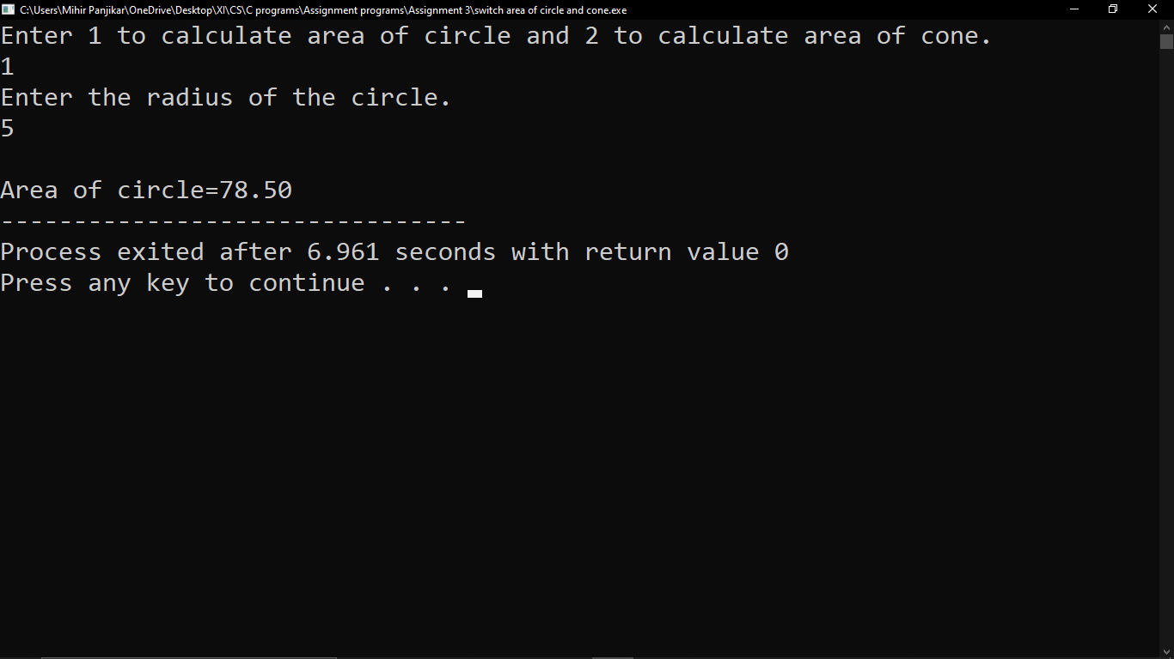}

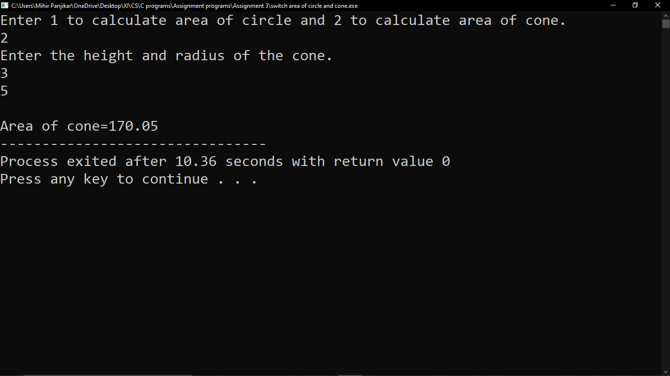

16) Write a C program to find the smallest number in a single dimensional array

#include<stdio.h>

int main()

{

int num[10],i,small;

printf("Enter 10 numbers\n");

for(i=0;i<=9;i++)

{

scanf("%d",&num[i]);

}

for(i=0;i<=9;i++)

{

printf("%d.",num[i]);

}

small=num[0];

for(i=0;i<=9;i++)

{

if(small>num[i])

small=num[i];

}

printf("\nsmallest number is %d",small);

}

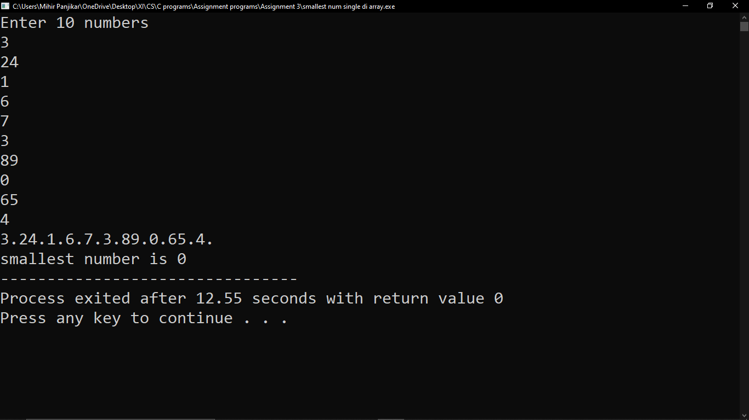

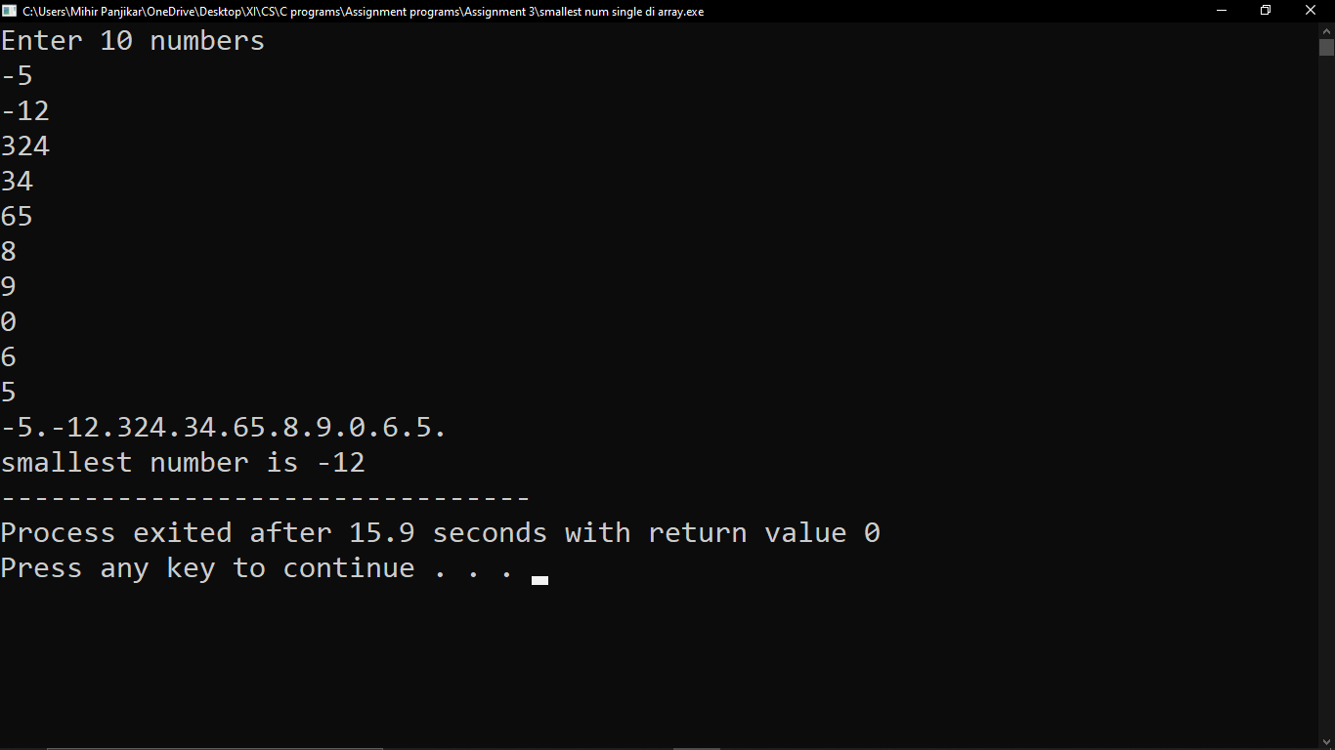

17) Write a C program to perform insertion and deletion of a number in an array.

#include<stdio.h>

int main()

{

int arr[50],key,loc,n,i,op;

printf("Enter size of the array:");

scanf("%d",&n);

printf("Enter %d elements\n",n);

for(i=0;i<n;i++)

{

scanf("%d",&arr[i]);

}

printf("Enter 1 insert an element in the array\nEnter 2 to delete an element in the array\n");

scanf("%d",&op);

switch(op)

{

case 1:

printf("Enter element to insert:");

scanf("%d",&key);

printf("Enter location to insert the element:");

scanf("%d",&loc);

for(i=n-1;i>=loc;i--)

{

arr[i+1]=arr[i];

}

arr[loc]=key;

printf("Resultant array:");

for(i=0;i<=n;i++)

{

printf("%d.",arr[i]);

}

break;

case 2:

printf("Enter location of the elemnt to be deleted:");

scanf("%d",&loc);

for(i=loc-1;i<n-1;i++)

{

arr[i]=arr[i+1];

}

if(loc>=n+1)

printf("Deletion not possible\n");

else

{

printf("Resultant array:");

for(i=0;i<n-1;i++)

{

printf("%d.",arr[i]);

}

}

break;

}



